**1.3 COUNTABLES AND UNCOUNTABLES**

|  |  |
| --- | --- |
| **COUNTABLE NOUNS** | **UNCOUNTABLE NOUNS** |
| Have both a singular and a plural form. | Have only one form (no plural) |
| *one tree two tree****s*** | *rain* |
| **Can** be preceded by ***a***, ***an*** or ***a number***. | **Can’t** be preceded by ***a***, ***an*** or ***a number***. |
| ***a*** *pencil ten pencils* | *rice* |
| **Can** be used with a verb in the **singular or plural**. | **Must** always be used with a verb in the  **singular**. |
| *The* ***book is*** *old. The* ***books are*** *old.* | *Sugar* ***is*** *sweet.*  *The weather here* ***is*** *great.* |

***Other examples:***

*The information is interesting.*

*I gave him advice.*

*I bought new furniture.*

*The news was thrilling.*

*We need more money.*

*I bought some bread.*

*He played some music.*

*He built software.*

*=> pour dénombrer ces mots, on utilise …*

**Exercises**

*memory, laptop, resolution, screen, plug-in, bandwidth, speed, watt, voltage, download, electricity, mouse*

1. Put the following nouns in one of the boxes below.

|  |  |  |
| --- | --- | --- |
| **COUNTABLE** |  | **UNCOUNTABLE** |
|  |  |  |

**1.4 Some - Any & co**



|  |  |  |  |
| --- | --- | --- | --- |
|  | image10.jpeg | image11.jpeg | image12.jpeg |
| image13.jpeg | image14.jpeg | image15.jpeg | image16.jpeg |
| I have got **a** friend. | I have got **some**  friend**s**. | I’ve got **some** sugar. |
| image17.jpeg | image18.jpeg | image19.jpeg | image20.jpeg |
| I haven’t got **a** friend. | I haven’t got **any**  friend**s**. | I haven’t got **any**  sugar. |
| image21.jpeg | image22.jpeg | image23.jpeg | image24.jpeg |
| Have you got **a** friend? | Have you got **any**  friend**s**? | Have you got **any**  sugar? |
|  | | | |
| image25.jpeg |  | image26.jpeg | image27.jpeg |
| image28.jpeg | 1. OFFER | image29.jpeg | image30.jpeg |
| Would you like **some**  sweet**s**? | Would you like **some**  water? |
| 2. REQUEST | image29.jpeg | image30.jpeg |
| Can I have **some**  sweet**s** please? | Can I have **some**  water please? |
| 3. SUGGESTION | image29.jpeg | image30.jpeg |
| Why don’t we eat  **some** sweet**s**? | Why don’t we drink  **some** water? |

e.g. *Here are* ***some*** *parting highlights from the show.*

*He makes* ***some*** *rather unorthodox shots.*

***Some*** *people’s first reaction is to think: oh that’s kind of creepy!*

**=> NO +NOUN = ANY + NEGATIVE:**

I have NO friends = I don’t have ANY friends

**=> composés de « some » et « any » + « no »: + -THING, -ONE / -BODY, -WHERE**

e.g. There is **something** I want to tell you.

I don’t **anything** in politics.

Do you have **anything** in your bag?

Is there **anywhere** you haven’t been yet?

I know **somewhere** he might be.

There is **somebody** at the door.

There is **nobody** at the door = there isn’t **anybody** at the door.

**Exercises**

**a) some, no, none or any ?**

1. I bought ………………….bread but I didn’t buy …………………..cheese.
2. I’m going to the post office. I need …………………stamps.
3. There aren’t ……………………shops in this street.
4. Makr and Lisa haven’t got ………………………….children.
5. I take …………………….sugar in my tea.
6. Would you like …………………………coffee ?
7. Can I have ………………………water ?
8. There was ………………………..wind yesterday.
9. I went out to buy ……………………..milk, we didn’t have ……………………
10. Do you know ……………………good hotels in London ?
11. Do you have ……………………..brothers or sisters ?
12. I don’t need ………………help.
13. A : How many questions did you answer correctly ? B : ……………….
14. She didn’t take …………………photographs, but I took …………………….
15. Where’s your luggage ? I haven’t got …………………
16. (showing 2 jackets) A : Which jacket are you taking ? B : …………………

**b) something, anything, nothing, someone, anyone, no one, somewhere, anywhere, nowhere ?**

1. A : what would you like to drink ? B : I’m so thirsty, give me ………………………… !
2. I’ve got ………………………..in my eye, it hurts.
3. Do you know ………………………about politics ?
4. Has ………………………..seen my keys ?
5. I went to buy a new pair of jeans but I didn’t buy ………………………
6. He has …………………………to go, can he stay here with us for the night ?
7. She told ………………………she was leaving.
8. ………………………………told me the meeting was cancelled.
9. I know …………………………………we could go on holiday next year !
10. This is a secret. Please don’t tell ……………………………….
11. Oscar Wilde used to say : « I have …………………………..to declare but genius ! »
12. He said ……………………..about what happened.
13. There isn’t ……………………………..in this bag.

**1.5 Other Quantifiers**

e.g. ***Many*** *snowmobile users are men. (< reading task)*

⚠ Instead of *a lot of*, we can use *lots of*. We can also use *plenty of* in affirmative sentences.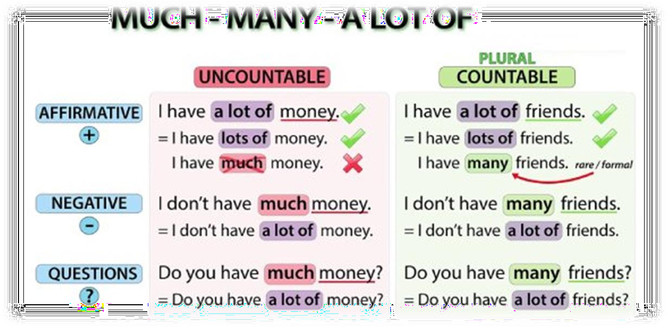

*I have* ***plenty of*** *money.*

*Do you have* ***lots of*** *friends?*

*Picking apples and stacking boxes [is] work that* ***lots of*** *people don’t want to do.*

|  |  |  |
| --- | --- | --- |
|  | **COUNTABLE NOUNS** | **UNCOUNTABLE NOUNS** |
| Meaning “hardly any” (almost none) | **few**  There are **few** restaurants around the city. | **little**  You have to do little shopping and cooking. |
| Meaning “some” | **a few**  Use a few left-overs to cook new meals. | **a little**  With a little imagination you will find your recipe. |

**Exercises: quantifiers**

1. Some of the sentences below contain mistakes. Correct them.

1. Have you got some change for the coffee machine? *…..*.........................................................

2. There isn’t any cables in the drawer. .......................................................................................

3. I always go out with some friends on Saturday. .......................................................................

4. Is there anybody in the office? .................................................................................................

5. Have you got any second hand laptop to sell? .........................................................................

6. Would you like some sugar in your coffee? .............................................................................

7. I need to add a memory to my desktop. ...................................................................................

8. I want to buy some CD. ...........................................................................................................

9. Is there some coffee in the box? ..............................................................................................

10. Has she got any pen drive? ...................................................................................................

11. How many money do you have in the bank? .........................................................................

12. How many voltage does your processor need? .....................................................................

13. With this application I can download many songs a day. .......................................................

14. You only need a little watts to use this computer. ..................................................................

15. This amplifier consumes a lot of electricity. ...........................................................................

16. How many does your computer cost? ...................................................................................

17. How much memory do you need to run this program? ...........................................................

18. On Youtube you can find plenty of videos about animals. ......................................................

19. How much bandwidth is necessary to watch a video stream? ...............................................

20. Do your shopping with a few mouse clicks. ...........................................................................

1. much, many, a lot (of), how much/many ?
2. Did you buy ………………………..things ?
3. ………………………………………did you pay for this jacket ?
4. Were there ……………………………………people you knew at the meeting ?
5. Did ……………………….people fail the examination ?
6. He hasn’t got ……………………..money.
7. …………………………………….students were absent ?
8. A : Did you like your trip to Turkey ? B : Yes, ………………….
9. A : Did you enjoy the movie ? B : No, not ……………………….
10. I have ……………………….friends who do that.
11. He has so ………………………..books.
12. He loves you so ……………………
13. I am hungry because I didn’t eat …………………….
14. I take ………………………..suagr in my coffee.
15. COMPLETE THE SENTENCES WITH MUCH, MANY, A LOT OF, FEW, A FEW, LITTLE, A LITTLE, A BIT :

1. Hurry up ! We haven't got ............... time.

2. He isn't ill, but he is ............... tired.

3. I can't lend you any money, I've only got ............... .

4. We've got ............... eggs. Shall we make an omelette ?

5. I must go to the greengrocer's. We've only got ............... vegetables.

6. There's not ............... traffic in town.

7. The cinema was full. There were ............... people there.

8. Has she got ............... friends ?

9. She wasn't angry, but she was ............... worried.

10. Did you get ............... cards on your birthday ?

11. We don't get ............... storms in Belgium.

12. Mike has made ............... progress and so is not feeling very pleased.

13. Could I have ............... cream, please ? Thank you.

14. I heard the cheapest ticket is £18. That's too ............... in my opinion.

15. I shall be away for ............... days from tomorrow.

16. ............... progress has been made in recent months.

17. I take many photos but nos as ............... as I used to.

18. Very ............... people were flying to that country because of terrorist activities.

19. Unfortunately I haven't got ............... time for watching sport at the moment, I'm rather busy.

20. ............... customers have come into the shop, it has been quiet.

1. Make questions as in the example.

Example: computers / you / have *How many computers do you have?*

1. memory / your computer / have ………………………………………………………

1. films / you / download in a week ………………………………………………………
2. bandwidth / your connection / support ………………………………………………………
3. bus speed / this processor / require ………………………………………………………

5. cores / this processor / have ………………………………………………………

7. CDs / you / need to buy ………………………………………………………

1. videos / you / have in your drive ………………………………………………………
2. power / your processor / consume ………………………………………………………
3. PCI slots / your motherboard / include ………………………………………………………
4. Choose among *a little*/*little*/*a few*/*few*.
5. I have *a little* / *little* / *a few* / *few* water left. There's enough to share.
6. I have *a little* / *little* / *a few* / *few* good friends. I'm not alone.
7. He has *a little* / *little* / *a few* / *few* education. He can't read or write, and he can hardly count.
8. There are *a little* / *little* / *a few* / *few* people she really trusts. It's a bit sad.
9. We've got *a little* / *little* / *a few* / *few* time at the weekend. Would you like to meet?
10. Julie gave us *a little* / *little* / *a few* / *few* apples from her garden. Shall we share them?
11. She has *a little* / *little* / *a few* / *few* self-confidence. She has a lot of trouble talking to new people.
12. There are *a little* / *little* / *a few* / *few* women politicians in the UK. Many people think there should be more.
13. It's a great pity, but the hospital has *a little* / *little* / *a few* / *few* medicine. They can't help many people.

I've got *a little* / *little* / *a few* / *few* cakes to give away. Would you like one?